CSS(Cascading Style sheets)

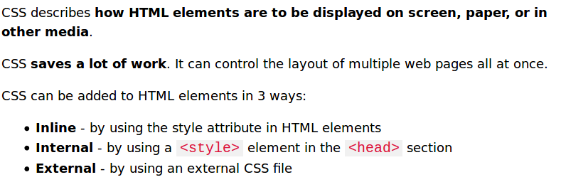

INLINE CSS

Inline CSS is done by using the style attribute in HTML elements.

The HTML style attribute has the following syntax:

<tagname style="property:value;">

**Example:**

<body style="**background-color**:powderblue**;**"></body>

<h1 style="**color**:blue;">This is a heading</h1>

<p style="color:red;">This is a paragraph.</p>

<h1 style="**font-family**:verdana;">This is a heading</h1>

<p style="font-family:courier;">This is a paragraph.</p>

<h1 style="**font-size**:300%;">This is a heading</h1>

<h1 style="**text-align**:center;">Centered Heading</h1>

INTERNAL CSS

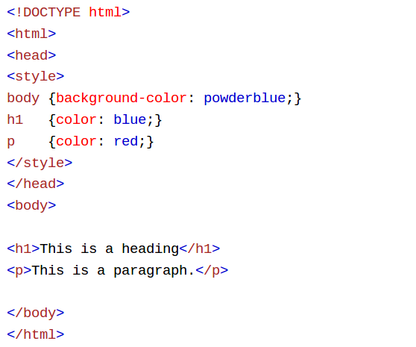

EXTERNAL CSS

CSS FILE:

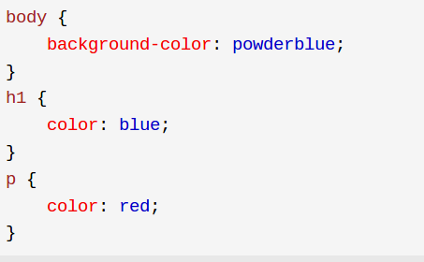

HTML FILE:

